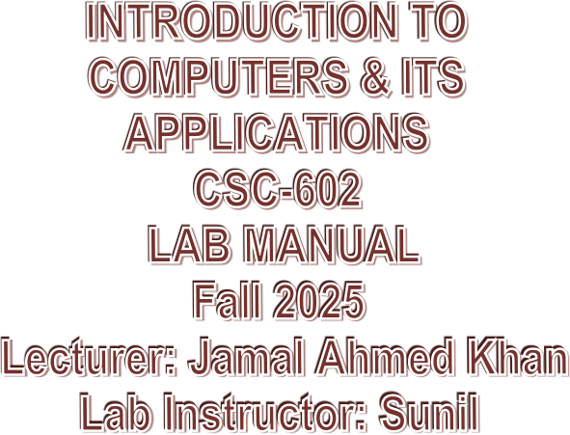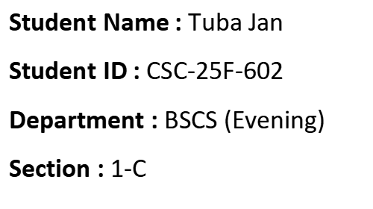

**ITC LAB TASK 01-02**

**MS Word :**

MS Word (Microsoft Word) is a word processing program for creating, editing, and formatting documents like letters, reports, and resumes. Developed by Microsoft, it is a key component of the [Microsoft Office suite](https://www.google.com/search?sca_esv=8d3d49c28ce86d19&sxsrf=AE3TifM3BMLpeEisNYemH32BQpfdLtBktA:1760631004418&q=Microsoft+Office+suite&sa=X&sqi=2&ved=2ahUKEwjGg-XMjamQAxUvgP0HHavjNK8QxccNegQIFBAB&mstk=AUtExfBPJB4mZHvFXSici3VQki0GK7ewkOaMhVvKInPSj1aAm9yom9fVUSohgDlVrrSTYEJ4TyCBvdBOLYkV6LOyNZK43FCw9xKdbmmZXxZOJ9MP1V8peUwDv8dlSxRBa0Bqa8ugNr4cIR9erenZI4aNnBJ8n_3Yt5-6dEE848_cAA128oM&csui=3) and includes features such as spell and grammar checking, text formatting, and the ability to insert images, tables, and charts.

**Key Features And Uses**

Document creation:

It allows users to create a wide variety of documents, from simple letters to complex reports and professional resumes.

Editing and formatting:

Word offers extensive tools for formatting text, and users can also apply borders, page colors, and other visual elements.

Collaboration:

Multiple users can work on a document together, with features to track changes and leave comments.

Built-in checks:

The program includes a spell checker and a grammar checker to help ensure documents are error-free.

Multimedia integration:

You can insert images, tables, charts, and even videos into your documents.

Templates:

Pre-designed templates are available to help users start creating documents more quickly.

Accessibility:

It is available on various platforms, including Windows, macOS, Android, and iOS, and has both desktop and online versions.

Main tabs and their functions

* **File:** For document management, including creating new documents, opening, saving, printing, and exporting.

* **Home Tab:**

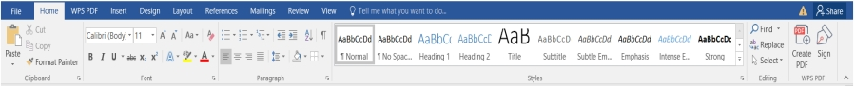

The default tab, containing groups for clipboard functions (copy, cut, paste), font formatting, paragraph styles, and editing tools like find and replace.

* **Insert Tab:**



Allows you to add content to your document, such as pages, tables, illustrations, links, headers, footers, and symbols.

* **Design Tab:**



Used for applying document themes, colors, and page backgrounds to create a consistent look and feel.

* **Page Layout Tab:**



Controls the overall appearance of the page, including margins, orientation, size, columns, and breaks.

* **References Tab:**



Contains tools for academic and professional documents, such as creating a table of contents, adding citations, and managing indexes.

* **Mailings Tab:**



Used for mail merge functions to create personalized documents like letters or emails for a list of recipients.

* **Review Tab:**



Facilitates collaboration with features like spelling and grammar check, track changes, and comments.

* **View Tab:**



Lets you switch between different document views (like Print Layout or Read Mode), adjust the zoom level, and show or hide rulers and gridlines.

**In conclusion :**

Microsoft Word is a powerful and versatile word processing program for creating, editing, and formatting text-based documents, and its advanced features make it an essential tool for individuals and organizations.

Q3: Write a report on any topic with proper formatting utilizing MS Word 2013.

**ITC LAB TASK-03** (Report)

* Margin alignment
* Cover page
* Header
* Footer
* Table of Content

# **COVER PAGE:**

A cover page in MS Word is a professional, formatted first page that introduces your document with elements like the title, author, images, and company logo. It serves to make your document more appealing and helps readers understand its purpose and context right away. Word provides a gallery of per-designed templates for easy creation, and you can also customize your own.

# **KEY FUNCTIONS OF A COVER PAGE:**

## **Identifies the document:**

It clearly states the title of the document and the name of the author or creator.

## **Enhances professionalism:**

It adds a polished and professional look to reports, papers, or other formal documents.

## **Adds context:**

It can include important details like the course name, instructor, and date for academic papers, or a company logo for business documents.

## **Makes a good first impression:**

It is the first thing a reader sees, so a well-designed cover page can make a positive and attractive introduction to your content.

The Impact of Social Media on Students

How Social Media Affects Mental Health

Negative Effects of Social Media

Tableof Contents

**ITC LAB TASK-03** (Report) 4

**COVER PAGE:** 5

**KEY FUNCTIONS OF A COVER PAGE:** 5

**Identifies the document:** 5

**Enhances professionalism:** 5

**Adds context:** 5

**Makes a good first impression:** 5

#### 1. Introduction

In the digital age, social media has become an inseparable part of students’ daily lives. While it offers opportunities for communication and learning, excessive use can impact mental well-being.

#### 2. What Is Social Media?

Social media refers to online platforms such as Instagram, Facebook, Ticktock, and X (formerly Twitter) that allow users to share content, communicate, and build communities.

#### 3. How Social Media Affects Mental Health

Constant exposure to others’ lives can create pressure, comparison, and sometimes lead to anxiety or depression among students.

#### 4. Positive Effects of Social Media

* Builds social connections
* Provides learning opportunities
* Enhances creativity and self-expression

#### 5. Negative Effects of Social Media

* Increases stress and anxiety
* Leads to procrastination
* Reduces sleep quality
* Promotes unrealistic comparisons

#### 6. Strategies for Healthy Social Media Use

#### 

6.1 Setting Time Limits

Students should monitor their daily screen time using built-in app timers.

6.2 Following Positive Accounts

Engaging with educational and motivational content improves mental wellness.

6.3 Taking Digital Detox

Occasionally logging off helps refresh the mind and regain focus.

#### 7. Real-Life Case Studies

A survey by Stanford University found that students who practiced digital detox reported 30% better concentration during exams.

#### 8. Conclusion

Social media can be both a blessing and a curse. With awareness and balance, students can enjoy its benefits without compromising mental health.

**Lab 04 Task:**

Q: Explore the MS Excel environment further and also become familiar with tabs.

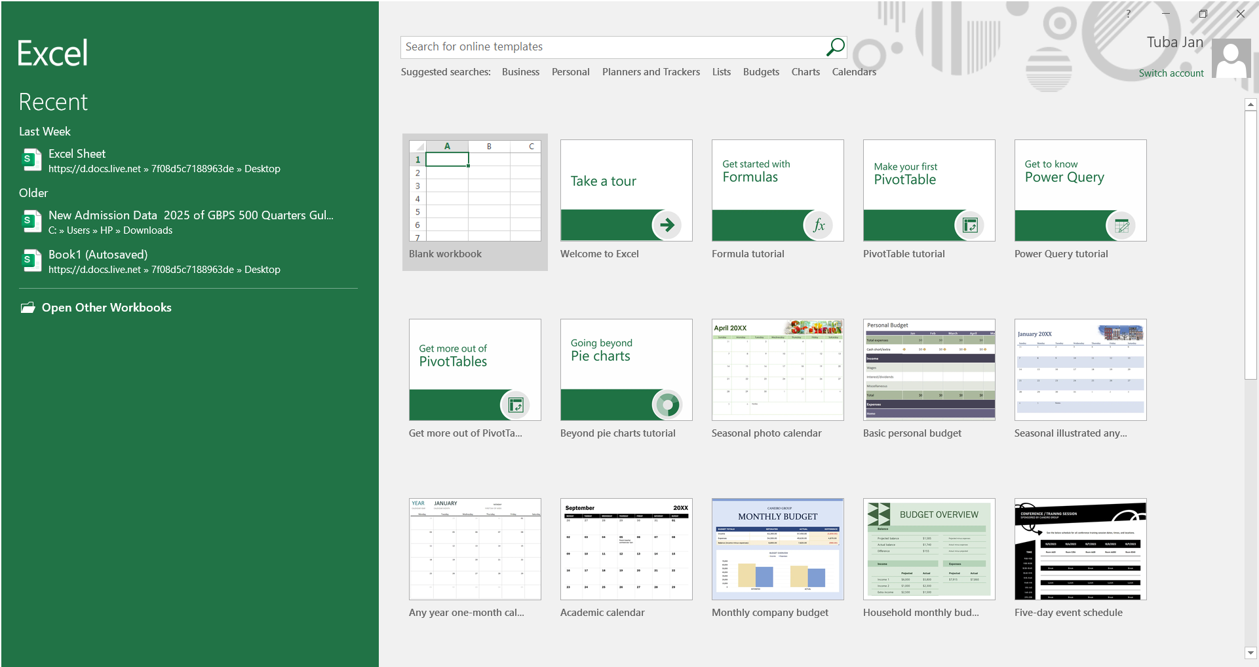

### Microsoft Excel is a spreadsheet software used for organizing, calculating, and analyzing data. It helps users create tables, perform formulas, make charts, and manage information easily. Excel is widely used in offices, education, finance, and daily tasks for data handling and quick calculations.

### **• File Tab:**

Used for managing Excel files, including creating new worksheets, saving, printing, and exporting.  
It handles document information, options, and sharing features.

### • **Home Tab:**

Contains commonly used tools like formatting, font styles, alignment, number formatting, and basic editing.  
It also includes clipboard functions (copy, paste), cell styles, and quick calculations.

### • **Insert Tab:**

Allows you to add charts, tables, illustrations, shapes, and pivot tables to your sheet.  
Useful for enhancing data visualization and inserting various objects.

### • **Page Layout Tab:**

Controls worksheet appearance, including margins, orientation, print area, and themes.  
Helps prepare data for professional printing and page formatting.

### • **Formulas Tab:**

Includes built-in functions, formula auditing tools, and calculation settings.  
Used for performing mathematical, logical, and statistical operations on data.

### • **Data Tab:**

Provides tools for sorting, filtering, validating, and importing data from external sources.  
Contains advanced options like data analysis, What-If tools, and connections.

### • **Review Tab:**

Used for spelling check, comments, protecting sheets, and tracking changes.  
Helps in collaborative work and securing spreadsheet content.

### • **View Tab:**

Lets you adjust workbook display settings, such as gridlines, zoom, and window arrangements.  
Allows switching between Normal View, Page Layout, and Page Break Preview.

### • **Developer Tab:**

Provides tools for creating macros, using Visual Basic for Applications (VBA), and adding form controls.  
Used for automation, advanced customization, and interactive worksheets.

**Lab 05 Task:**

Q: Create a professional result sheet for 15 university students in Excel, including subject marks, total, grade, CGPA, and remarks. Apply conditional formatting, add the university logo, and format the table neatly.

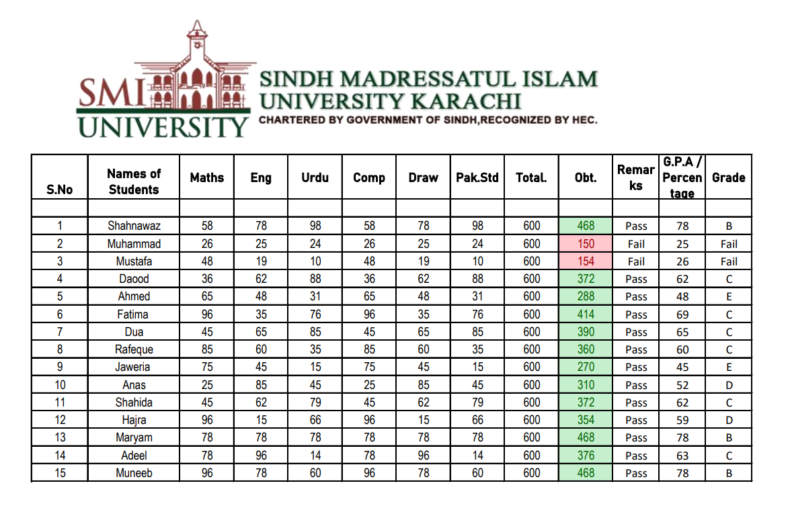

**Lab 06 Task:**

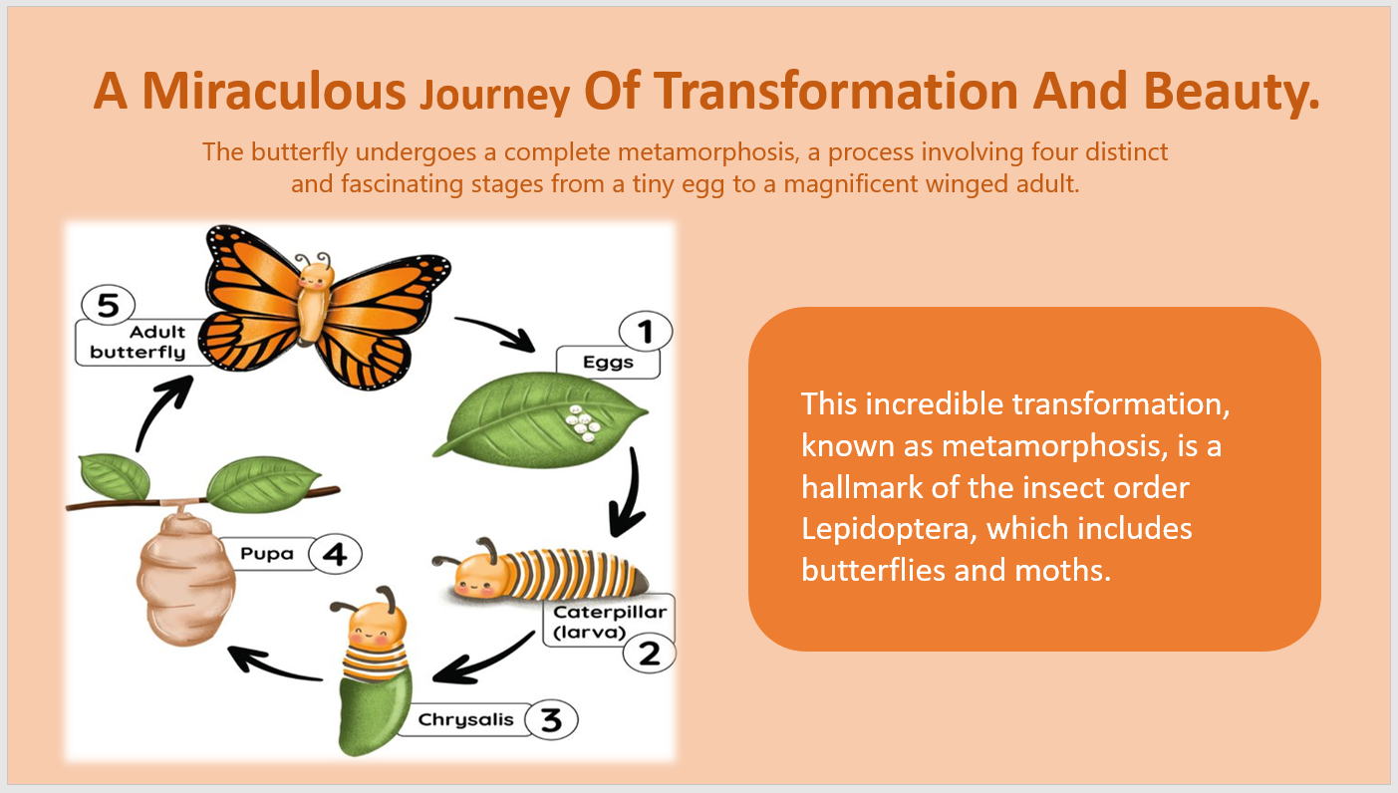Q: Make a presentation in power point on any suitable topic.

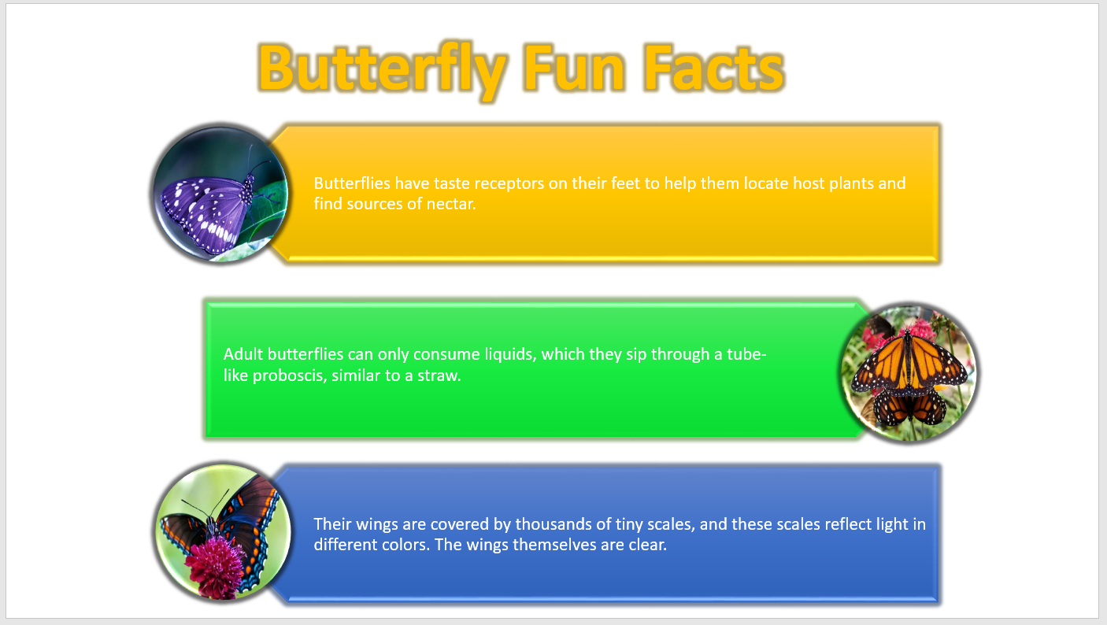

**Lab 07 Task:**

Q: Create a neat and well-structured CV webpage containing your objective, skills, education, experience, hobbies, a meaningful quote, and personal information. The content should be properly organized and clearly presented.

<!DOCTYPE html>

<html lang="en">

  <head>

    <meta charset="UTF-8" />

    <meta name="viewport" content="width=device-width, initial-scale=1.0" />

    <title>ITC LAB Assignment_07</title>

  </head>

  <body>

    <center>

      <h1>ITC Lab &nbsp;07</h1>

    </center>

    <center>

      <h2>Tuba Jan CSC-25F-602</h2>

    </center>

    <hr />

    <h2>Objective</h2>

    <p>

      “I have a deep understanding of technology and am passionate about

      nurturing that love. As an IT professional, I'm committed to my tasks and

      always ready to face challenging assignments. Data is the lifeblood of our

      industry, and I play with information, create it, and work with it.

      Innovation and proficiency in modern technology drive my work.”

    </p>

    <h2>Skills & Abilities</h2>

    <b>

      <ul>

        <li>HTML</li>

        <li>CSS</li>

        <li>Turboo</li>

        <li>fluent in speaking English</li>

        <li>Office Automation</li>

      </ul>

    </b>

    <h2>Education</h2>

    <ul>

      <li>

        <i><strong>School </strong></i>from Iqra Huffaz Girls Secondary School

        &nbsp;&nbsp;&nbsp;&nbsp;&nbsp;&nbsp;(2020-2021)

      </li>

      <li>

        <i><strong>College</strong></i> from Bahria College Karachi NORE-1

        &nbsp;&nbsp;&nbsp;&nbsp;&nbsp;&nbsp;(2022-2024)

      </li>

    </ul>

    <h2>Experience</h2>

    <p>

      I am very fresher in this feild and may Allah (S.W.T) give me strength to

      make a very strong expereince

    </p>

    <h2>Interest & Hobbies</h2>

    <ul>

      <li>Reading</li>

      <li>Photography</li>

      <li>Programming</li>

      <li>Watching documentries</li>

      <li>Playing badmaintain</li>

    </ul>

    <h2>

      I personally like

      <q><abbr title="Beyoncé Giselle Knowles">Beyoncé's</abbr></q> this Quote

    </h2>

    <blockquote

      cite="https://www.elle.com/uk/life-and-culture/news/a29993/beyonce-quotes-to-live-your-life-by/"

    >

      "Your self-worth is determined by you. You don't have to depend on someone

      telling you who you are."

    </blockquote>

    <ol>

      <h2>Personal Information</h2>

      <li>

        <b>Date of Birth : 7 <sup>th</sup> /Jan /2006</b>

      </li>

      <li><b>Religion : Islam</b></li>

      <li><b>Birth Place : karachi</b></li>

      <li><b>Nationality : Pakistani</b></li>

    </ol>

    <hr />

    <center>© 2024 Tuba Jan | All right Reserved</center>

  </body>

</html>

**Output**

